Part Number: PT936-48160-XX

Kit Contents

|  |  |  |
| --- | --- | --- |
| Item # | Quantity Reqd. | Description |
| 1 | 1 | Front Driver Door Guard (Reference Pink Sticker) |
| 2 | 1 | Front Passenger Door Guard  (Reference Blue Sticker) |
| 3 |  | Rear Driver Door Guard  (Reference Green Sticker) |
| 4 |  | Rear Passenger Door Guard  (Reference Yellow Sticker) |
|  |  |  |

Hardware Bag Contents

|  |  |  |
| --- | --- | --- |
| Item # | Quantity Reqd. | Description |
| 1 | N/A |  |
|  |  |  |

Additional Items Required For Installation

|  |  |  |
| --- | --- | --- |
| Item # | Quantity Reqd. | Description |
| 1 | A/R | DIO: Simple Green All-Purpose Cleaner – Full Strength  PPO: VDC Approved Cleaner |
| 2 | A/R | Lint-free towels |
| 3 | A/R | Blue painter’s masking tape |
| 4 | 1 | Scissors |

Conflicts

|  |
| --- |
| None |

Recommended Tools

|  |  |
| --- | --- |
| Personal & Vehicle Protection | Notes |
| None |  |
| Special Tools | Notes |
| PPO Magnetic Template | IADS p/n =  RX16-0007-01, -02, -03, -04 |
| Sealant Adjustment Tool | IADS p/n=  HIG11-D5-03 |
| DIO Paper Door Templates | See last page of these  instructions |
| Nylon Removal Tool(NRT) | SST p/n =  00002-06002-01 |
| Installation Tools | Notes |
| 12-oz. rubber mallet | IADS p/n =PRI10-D5-02  Vaughn, p/n = SF12 |
| Special Chemicals | Notes |
| Simple Green or VDC approved cleaner |  |

General Applicability

|  |
| --- |
| All |

Recommended Sequence of Application

|  |  |
| --- | --- |
| Item # | Accessory |
| 1 | Body Side Molding |
| 2 | Door Edge Guard |

\*Mandatory

Vehicle Service Parts (may be required for reassembly)

|  |  |  |
| --- | --- | --- |
| Item # | Quantity Reqd. | Description |
| 1 |  |  |
|  |  |  |

Legend

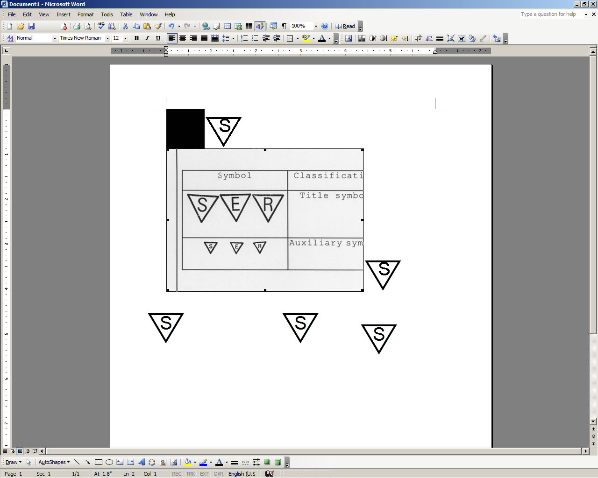

**STOP:** Damage to the vehicle may occur. Do not proceed until process has been complied with.

**OPERATOR SAFETY:** Use caution to avoid risk of injury.

**CAUTION:** A process that must be carefully observed in order to reduce the risk of damage to the accessory/vehicle and to ensure a quality installation.

**TOOLS & EQUIPMENT:** Used in Figures calls out the specific tools and equipment recommended for this process.

**REVISION MARK:** This mark highlights a change in installation with respect to previous issue.  
  
**SAFETY TORQUE:** This mark indicates that torque is related to safety.





Care must be taken when installing this accessory to ensure damage does not occur to the vehicle. The installation of this accessory should follow approved guidelines to ensure

a quality installation.

These guidelines can be found in the "Accessory

Installation Practices" document.

This document covers such items as:-

• Vehicle Protection (use of covers and blankets, cleaning chemicals, etc.).

• Safety (eye protection, rechecking torque procedure, etc.).

• Vehicle Disassembly/Reassembly (panel removal, part storage, etc.).

• Electrical Component Disassembly/Reassembly (battery disconnection, connector removal, etc.).

Please see your Lexus dealer for a copy of this document.

|  |  |  |  |  |  |
| --- | --- | --- | --- | --- | --- |
| **FRONT DOOR TEMPLATES** | **REAR DOOR TEMPLATES** | | **CLEANER** | **NYLON REMOVAL TOOL** | **MALLET** |
| **TAPE** | **SCISSORS** | **­­­­­**  **LINT FREE** |
| **FRONT DOOR EDGE GUARDS**  ­­ | | **REAR DOOR EDGE GUARDS**  **DOOR EDGE GUARDS** | | | |

1

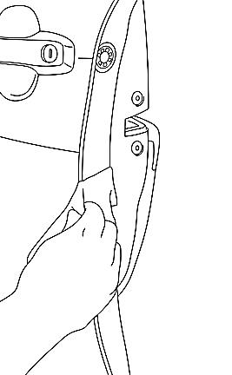

**CLEAN ALL DOOR EDGES**



**x4**

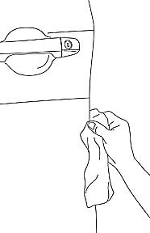

**DRY ALL DOOR EDGES**



**SQUEEK**



**ROTATE TOWEL AFTER EACH WIPE**



2

****

3

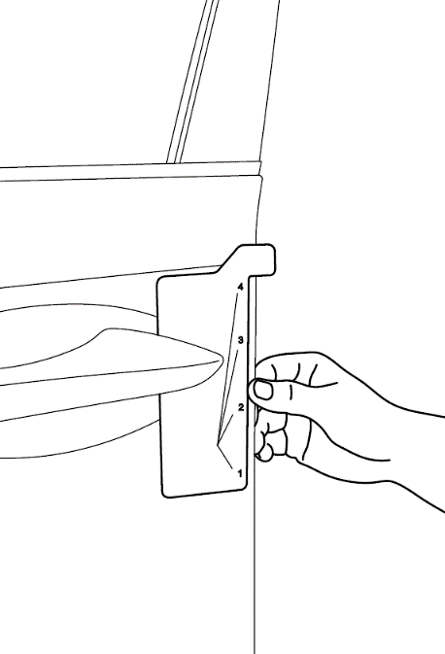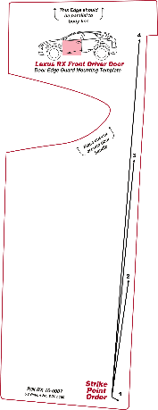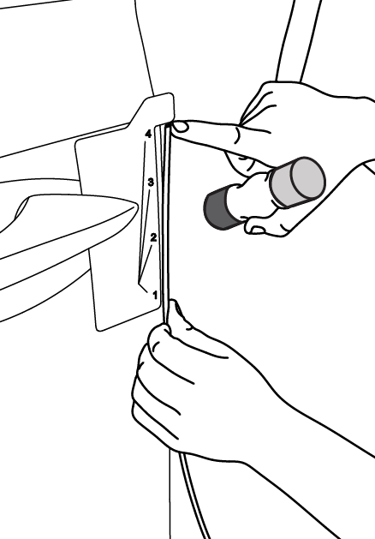

**ALIGN**

4



5

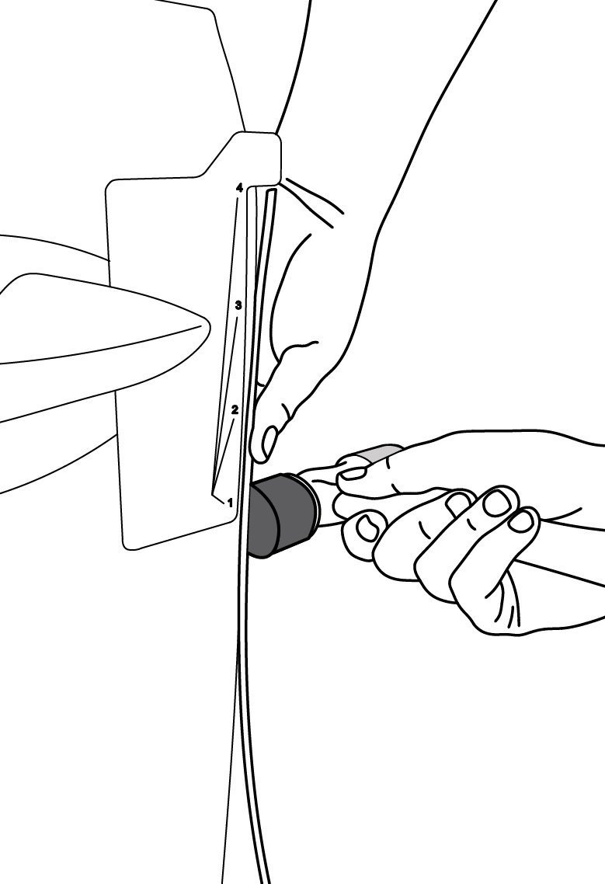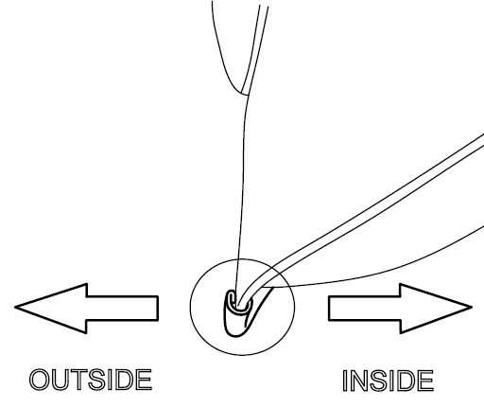

**START**

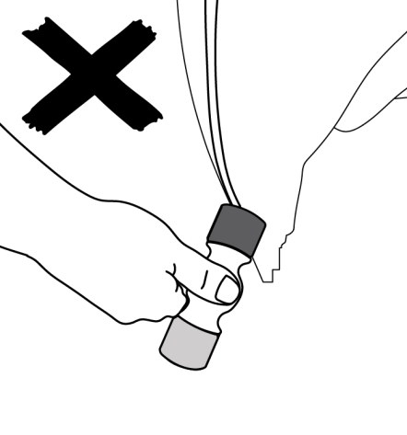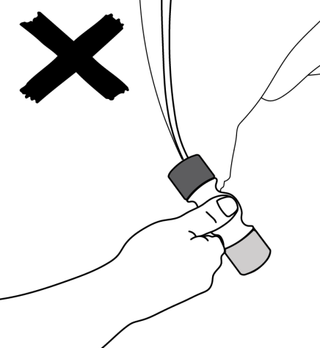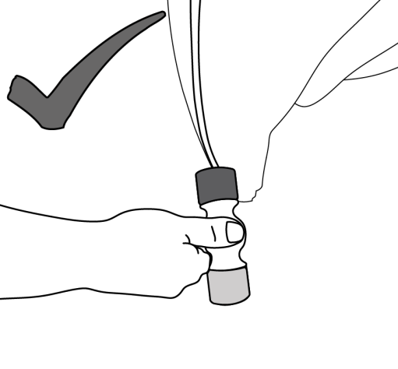

**ENSURE MALLET HEAD IS PERPENDICULAR TO THE EDGE OF THE DOOR**

6

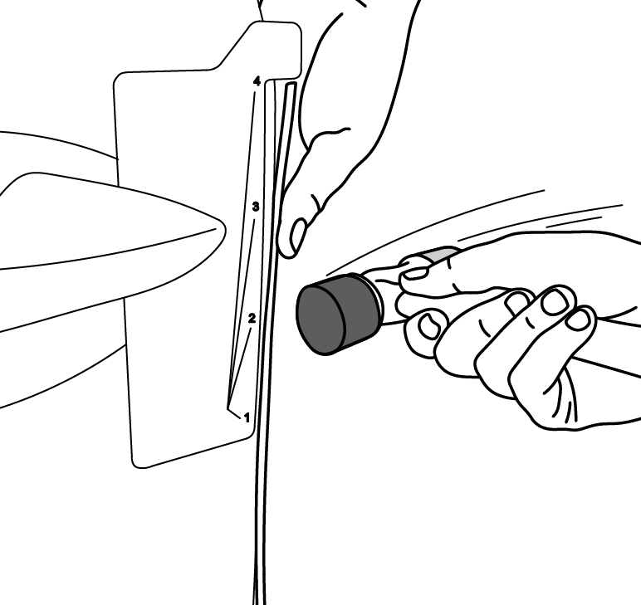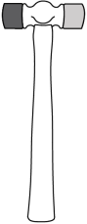

~½”

7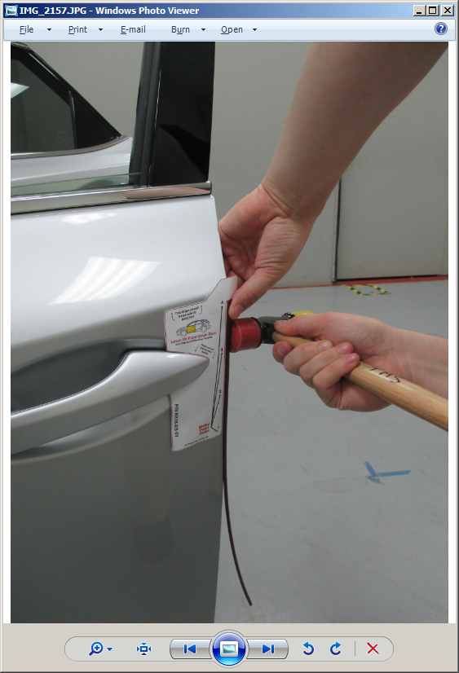

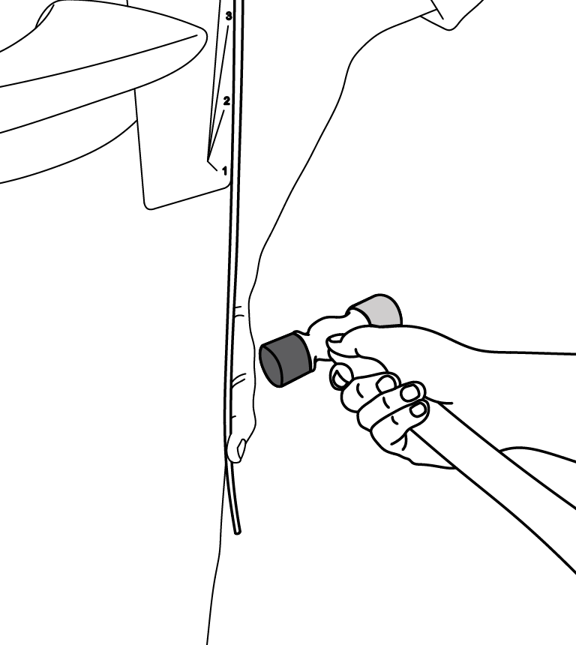

~½”





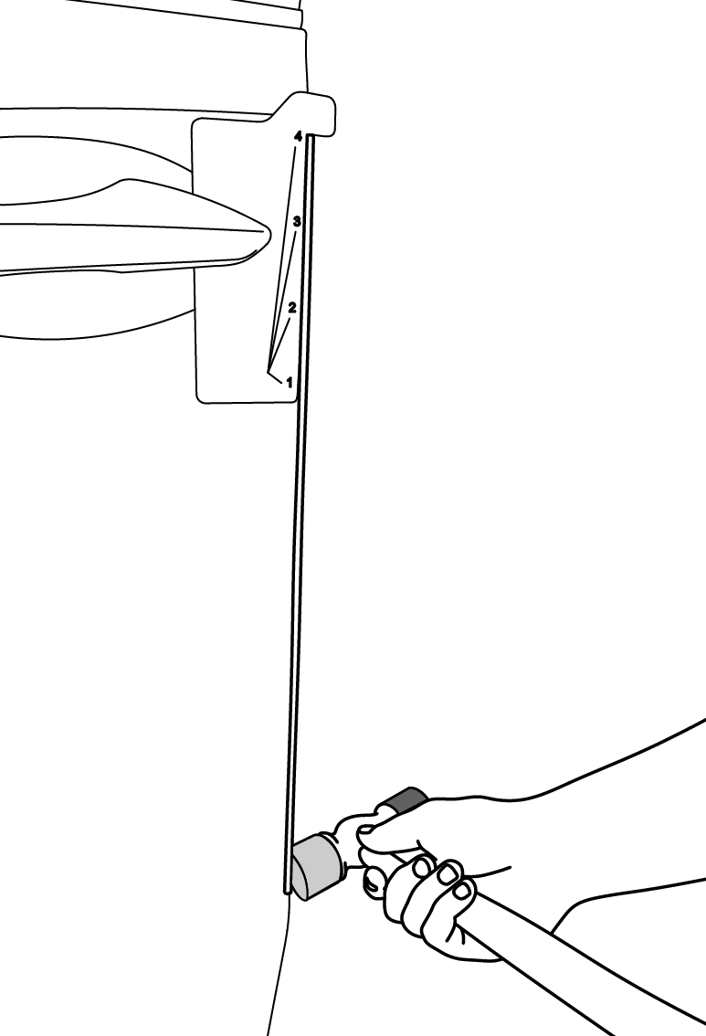

THUD

6

&

7

~1”

=



THUD

**SEE PAGE 8 FOR INSTALLATION CHECKLIST**

**USE YELLOW SIDE OF MALLET HEAD**

8

9

REPEAT ALL DOORS

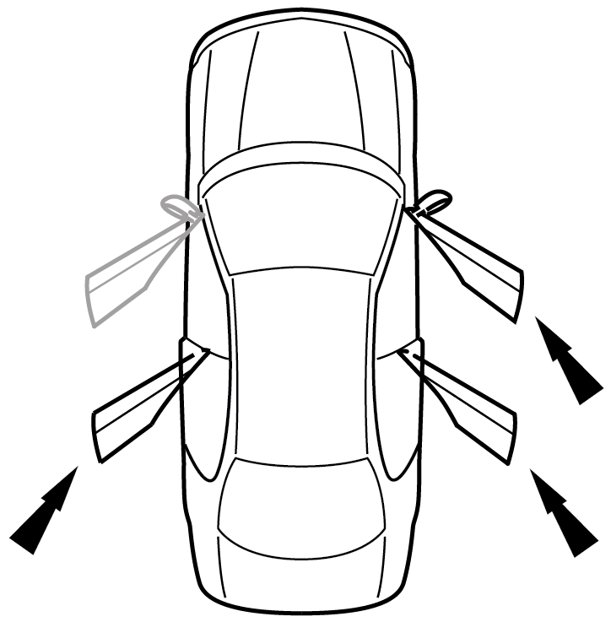



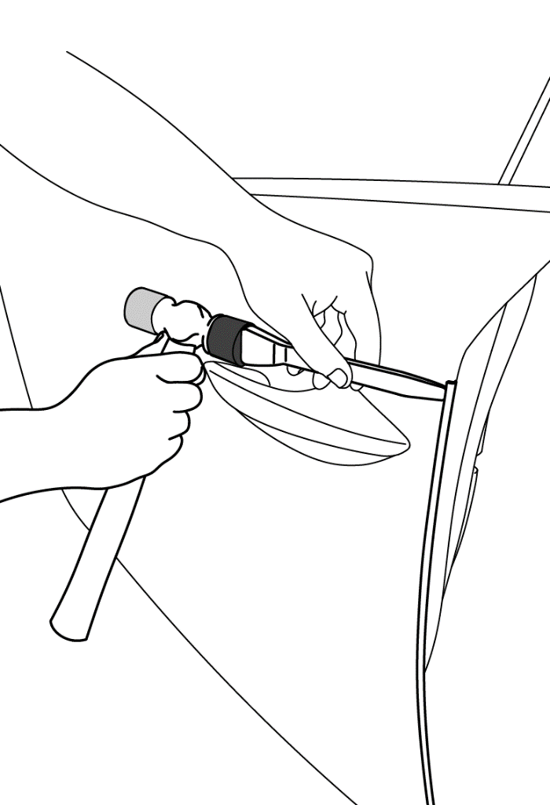

~4”

DEG REMOVAL



**START !!**



~½”

10

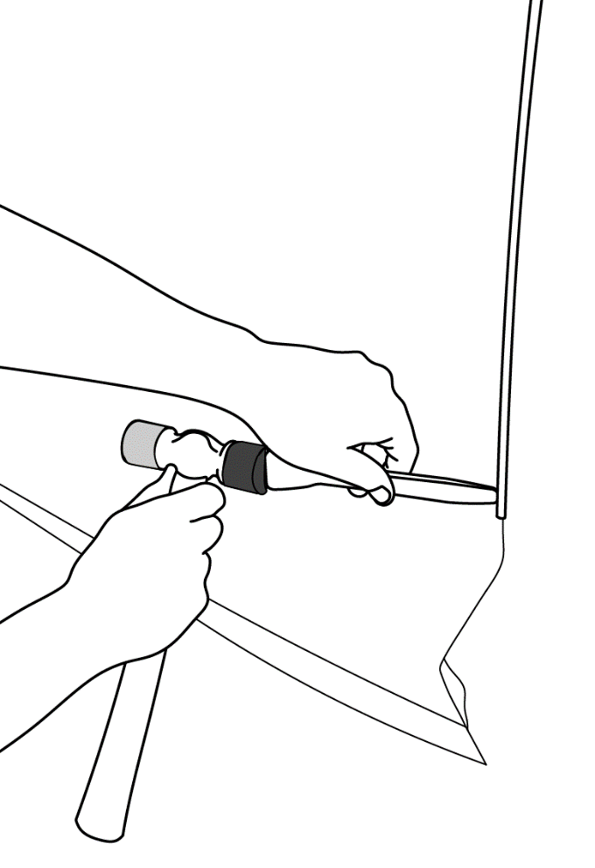

~½”

**THIS PAGE PPO ONLY**

caution_2

**NOTE:** The adjustment tool can be used if sealant is close to the door’s edge. This must be done to allow for proper **Door Edge Guard** installation (Fig. 1-1).

Fig. 1-1

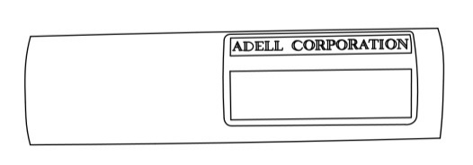

Sealant Adjustment Tool HIG11-D5-01



Align the adjustment tool to the edge of the door, with the angle edge positioned toward the inside of the door (Fig. 1-2).

Fig. 1-2

Depth gage (Side view)

Use the adjustment tool as a depth gage down the entire length of the door’s edge. This is to verify that the sealant material is back away from the edge of the door to allow for proper Door Edge Guard installation.

Align the adjustment tool to the edge of the door, with the angle edge positioned toward the inside of the door (Fig. 1-3).

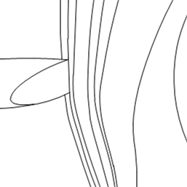

Fig. 1-3

Angle tip in contact with sealant

With the adjustment tool angle tip in contact with the sealant material, push the adjustment tool inward so that the notched section of the tool is in complete contact with the door’s edge. Continue down the door’s edge or sections of the door’s edge that requires adjustment.

Accessory Function Checks

Confirm all Door Edge Guards are fully seated.

Vehicle Function Checks

Vehicle door operation.

Look for a fairly consistent gap between the DEG and adjoining vehicle panels.

**NOTE:** Normal vehicle manufacturing tolerances may exist that are not a consequence of an improperly seated DEG installation

Confirm both doors open and close without interference from DEG or Body Side Molding (if installed).

Vehicle Appearance Check

After accessory installation and removal of protective cover(s), perform a visual inspection.

Ensure no damage (including scuffs and scratches) was caused during the installation process.

(For PPO installations, refer to TMS Accessory Quality Shipping Standard.)

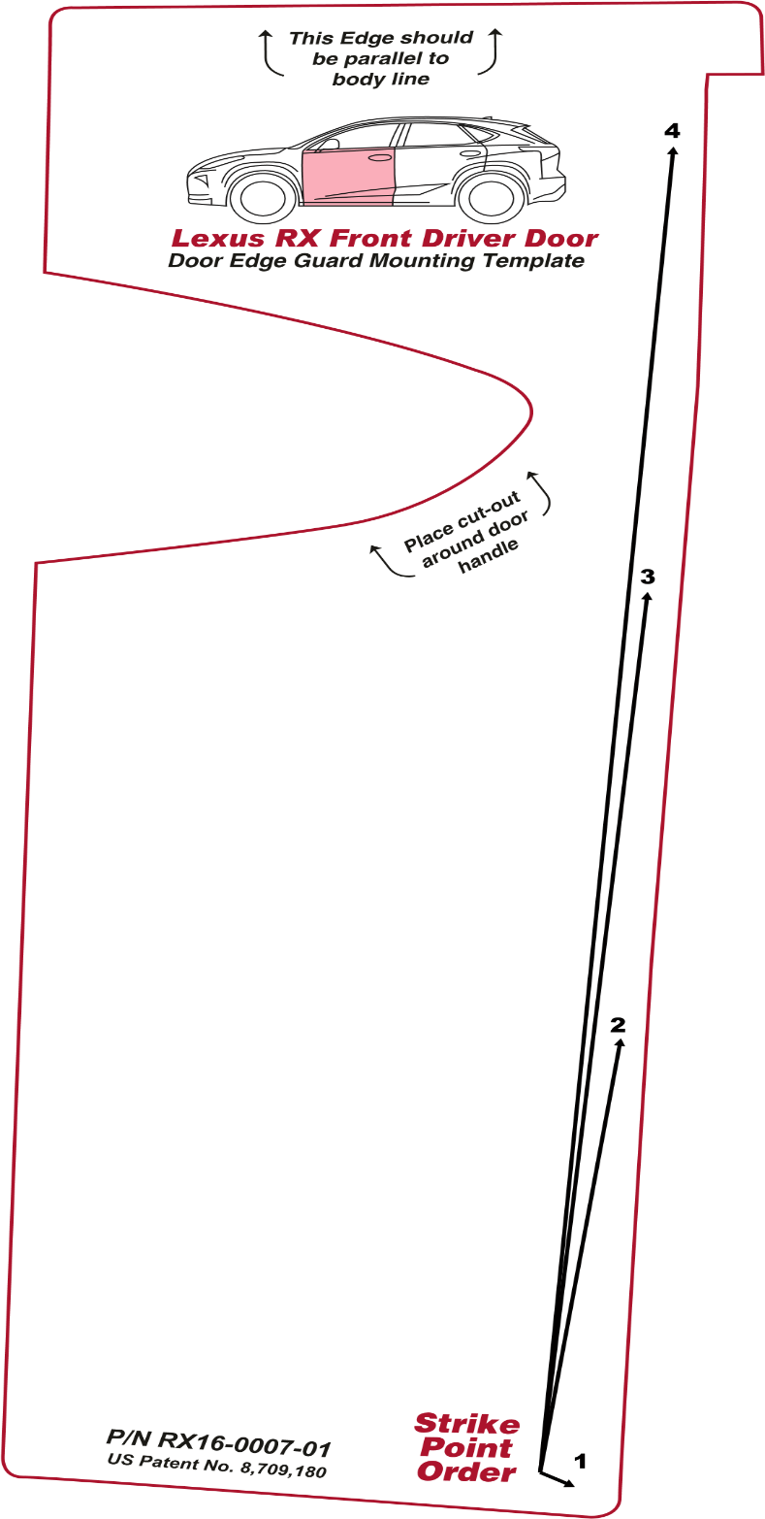

0”

1”

2”

3”

4”

5”

Dealer Installation Note: Check the above scale to ensure it is 1:1. Adjust on photocopier if it is not to scale. If this is a pdf document, set the “Page Scaling” to “None” in the Print dialogue box prior to printing.

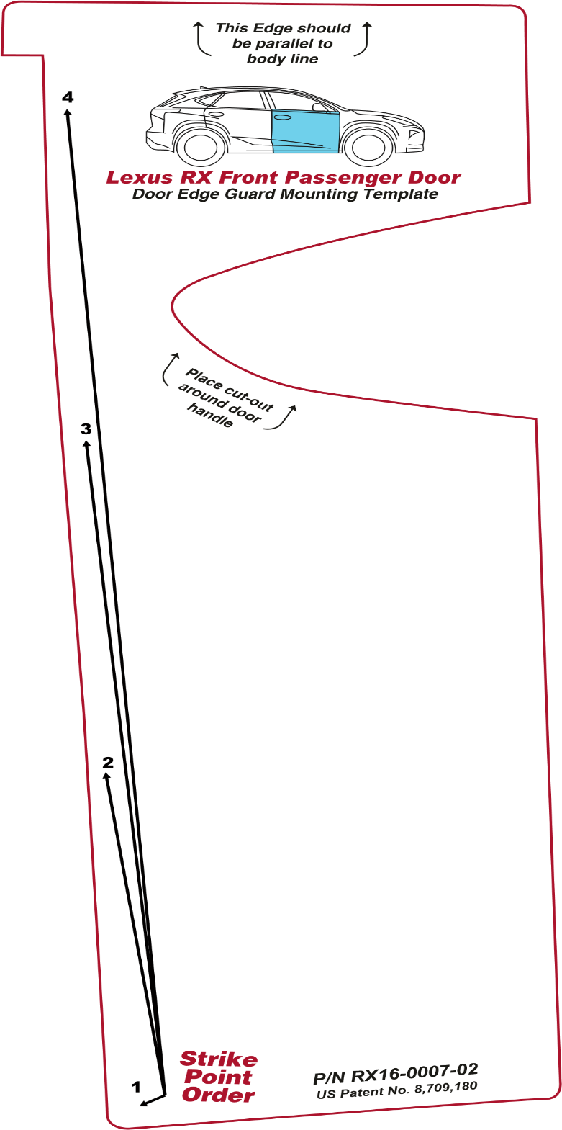

Dealer Installation Note: Check the above scale to ensure it is 1:1. Adjust on photocopier if it is not to scale. If this is a pdf document, set the “Page Scaling” to “None” in the Print dialogue box prior to printing.

0”

1”

2”

3”

4”

5”

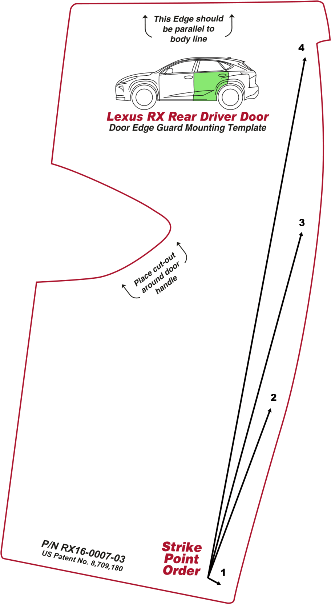

0”

1”

2”

3”

4”

5”

Dealer Installation Note: Check the above scale to ensure it is 1:1. Adjust on photocopier if it is not to scale. If this is a pdf document, set the “Page Scaling” to “None” in the Print dialogue box prior to printing.

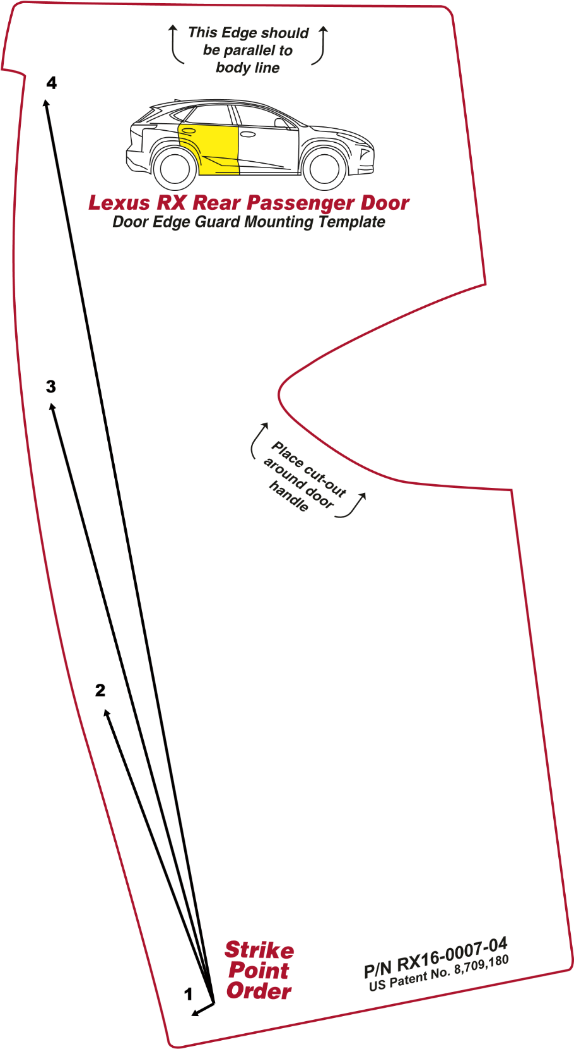

0”

1”

2”

3”

4”

5”

Dealer Installation Note: Check the above scale to ensure it is 1:1. Adjust on photocopier if it is not to scale. If this is a pdf document, set the “Page Scaling” to “None” in the Print dialogue box prior to printing.